IBM Watson Bluemix Workshop

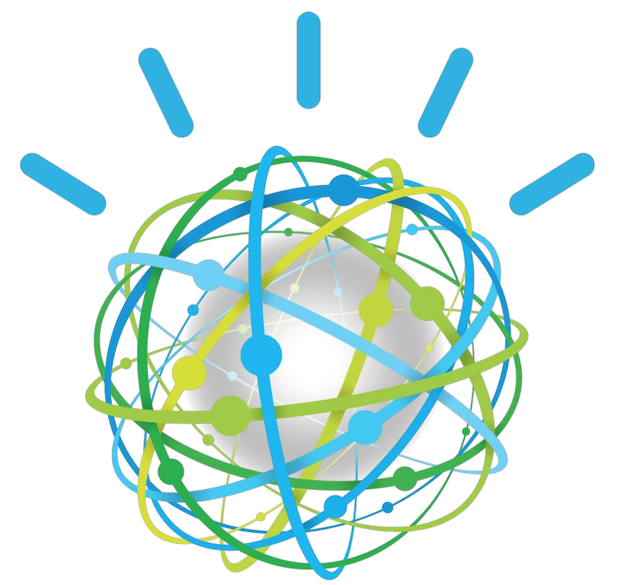
Building Apps and Augmenting them with Cognitive Services
Prepared by Armen Pischdotchian

UC Berkeley: November 17, 2015

Overview
What is Bluemix you ask? Bluemix is an implementation of IBM's Open Cloud Architecture, leveraging Cloud Foundry to enable developers to rapidly build, deploy, and manage their cloud applications, while tapping a growing ecosystem of available services and runtime frameworks. You can view a short introductory video here: http://www.ibm.com/developerworks/cloud/library/cl-bluemix-dbarnes-ny/index.html

It is strongly recommended that you perform all the steps and downloads outlined in the prerequisite section.
In this workshop, the instructor and the participants will complete the following workshop in parallel:
You begin with the Personality Insights (PI) service, where you analyze a particular document written by one individual. The analysis reveals a person under stress and some of the traits garnering high scores from the PI service will prompt you to address those concerns from a second service, the Question Answer (QA). The answers provided are from a built-in demo corpus and the domain knowledge is the healthcare pipeline. Additionally, the responses are also analyzed by the Keyword Extraction capability of the AlchemyAPI service. These keywords, terms, might then prompt you to further ask related questions as you try to learn more about the havoc that stress can cause on the individual.

Prerequisite
This section provides instructions to help you get started quickly with the IBM Watson™ Developer Cloud services using Node.js as your programming runtime environment. To make it easy to get up and running with a functional application that uses the REST Application Programming Interface (API) for any Watson service, IBM provides a Node.js package with wrappers that simplify application development. The package includes simple command-line example applications to let you experiment with any of the available services. Complete the following steps to satisfy the prerequisites
- Obtain Bluemix credentials:
  - Direct your browser to the Bluemix home page: https://console.ng.bluemix.net/home/
  - Click Sign Up on the top right.
  - Enter requested information and click Create Account.
- Install the Node.js runtime:
The default installation includes both the runtime and package manager. Make sure to include the installed binaries on your PATH environment variable after installation (typically, the default installation locations that the installer selects does the inclusion).
  - Direct your browser to the nodejs.org web site: https://nodejs.org/download/
  - Click Downloads.
  - Select and install the installer (not the binary) appropriate for your operating system.
- Install the cf command line
  - Direct your browser to a GitHub repository: https://github.com/cloudfoundry/cli/releases
  - Download and install the most recent installer appropriate for your operating system.
- Extract the WorkshopPackageAsset2.zip
This package contains basic code to get you started with an app front page that already has the text entry boxes prebuilt for you.
  - Direct your browser to a GitHub repository: https://github.com/
  - Search for bluemix-workshop.
  - Scroll down and select: apischdo/Bluemix-workshop-assets
  - Download all zip files from the Download button to the bottom right of the page.
  - Extract the contents of the WorkshopPackage.zip file in a temporary location on your local system.

- Download the JSON pretty print add-on specific for you browser
In order to make better sense of the output of an analyzed text, or a DeepQA response, it would help to have the returned JSON output, which opens in another tab, appear in a readable format. JSON pretty print add-on, specific to your browser and OS, is a highly recommended download. The image below is an example of Google search for such download. Choose a plugin specific for the browser you are using.

- Download OS appropriate code-friendly editing tool
If you are using a PC, we recommend using Notepad ++
If you are using Mac, we recommend Sublime Text
- Obtain the AlchemyAPI service access key
Unlike other Watson services where the auto generated basic auth credentials serve as the binding criteria between your app and the services, known as VCAP_SERVICES, AlchemyAPI uses access keys to accomplish the same tasks. To obtain that key, complete the following steps:
- Provided that you already have an account on Bluemix and can access the Catalog tab and see all the available services, find and click the AlchemyAPI service.
- Click VIEW DOCS.
- In the resulting page, click the link API key here.
- Fill in the requested information and click Register for API Key.
- Once you have received the key, copy it in a secure location for future use.

